**Week 1 and 2: Brief research on the Project Topic and Finalisation of materials required**

***Introduction:***

*This project introduces an intelligent double-door automation system with adaptive single-door conversion for energy efficiency. Using sensors (PIR, LiDAR) and motorized actuators, it dynamically switches between full dual-door operation (high traffic) and single-door mode (low traffic), reducing HVAC losses and mechanical wear. Safety features include obstacle detection and speed control. Ideal for hospitals, malls, and smart buildings, the system enhances accessibility while optimizing power consumption. Future upgrades may include AI-based traffic prediction for smarter operation.*

***About Different Door Swing Mechanism:***

*A swinging door operates as a constrained rotational system where hinge mechanics mediate the conversion of linear force into angular displacement. The motion follows damped harmonic principles, with friction and inertial forces creating characteristic acceleration-deceleration profiles. Hinge design introduces critical tribological considerations - the interface between pin and bearing must minimize static friction while maintaining structural integrity under cyclical loading. Modern variants incorporate energy management systems, where hydraulic dampers or torsional springs alter the system's dynamic response. Automation transforms this mechanical system into a control theory problem, with servo mechanisms compensating for nonlinear mass distribution and environmental disturbances. Material selection becomes paramount, as grain structures in metal hinges must withstand shear stresses while polymer components require precise hardness coefficients to prevent deformation. The mechanism's elegance lies in its deceptive simplicity - what appears as basic rotation represents a carefully balanced equilibrium between applied torque, frictional losses, and restorative forces, making it a microcosm of broader mechanical engineering principles.* *Single doors prioritize simplicity and reliability, while double doors enable larger openings but require precise dynamic coordination and maintenance. The choice depends on span requirements versus tolerance for synchronization complexity.*

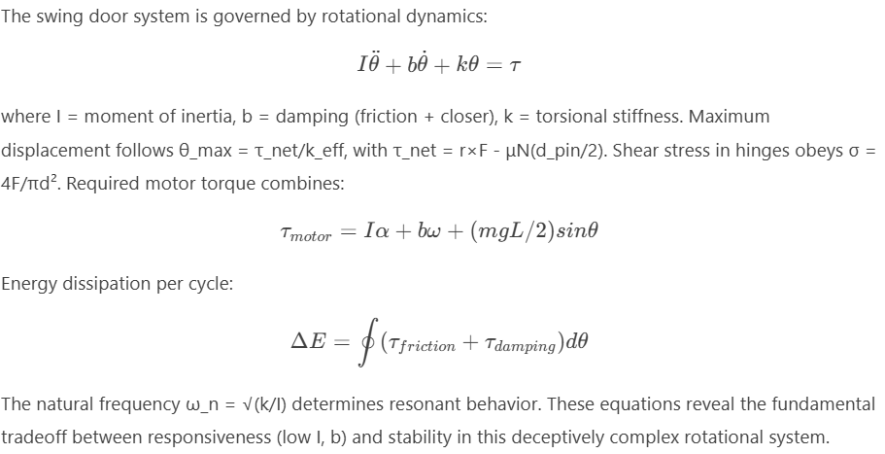

***Single Door vs Double Door Swing Mechanism:***

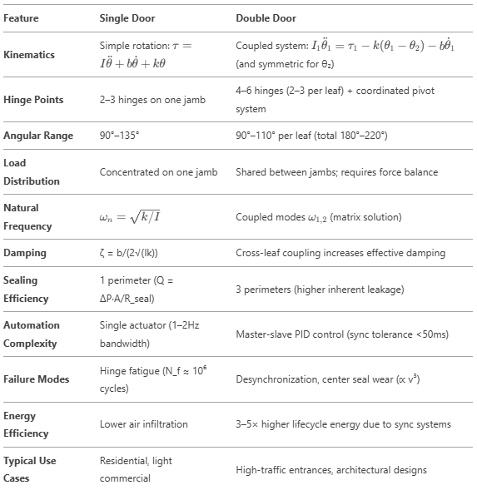

***Brief overview of different electronic components used:***

***PIR SENSOR***

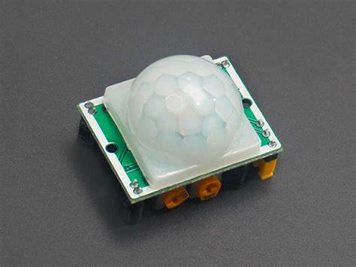

*Passive Infrared (PIR) sensors detect motion by measuring changes in infrared radiation from objects like humans or animals. They use pyroelectric sensors and Fresnel lenses to achieve detection ranges of 3–12m with a 110°–180° field of view. These sensors output digital or analogy signals, making them ideal for automation, security systems, and IoT devices. Advanced versions feature adjustable sensitivity, dual-element detection, and low-power operation (3.3V–5V). While cost-effective and reliable, PIR sensors require line-of-sight and can trigger false alarms from pets or thermal fluctuations. Innovations like AI-enhanced PIR arrays and hybrid sensor systems are improving accuracy for smart home and industrial applications.*

***MICROWAVE SENSOR (HB100)***

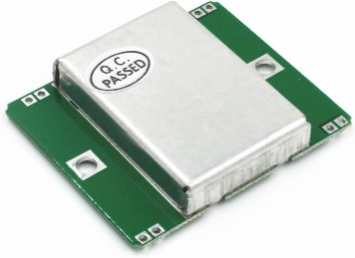

*Microwave sensors utilize high-frequency electromagnetic waves (1–30 GHz) to detect motion, speed, and distance via Doppler effect or time-of-flight analysis. Unlike PIR sensors, they actively emit RF signals, enabling penetration through non-metallic materials and operation in low-visibility conditions. Advanced variants like FMCW radar and UWB radar enhance precision, while AI-driven signal processing reduces false alarms. Though susceptible to RF interference, their robustness in harsh environments makes them ideal for autonomous vehicles, smart infrastructure, and industrial automation. Emerging mm Wave radar and cognitive sensing promise finer object recognition, positioning microwave sensors as critical enablers of next-gen IoT and AI-powered surveillance systems.*

***SERVO MOTOR***

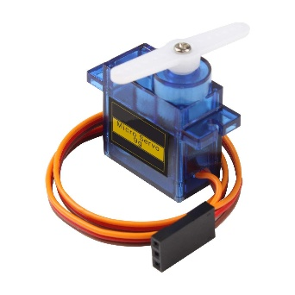

*Servo motors are high-precision electromechanical actuators employing closed-loop feedback (encoders/resolvers) and PID control for dynamic error correction. They utilize brushless DC or AC synchronous designs with field-oriented control (FOC) for optimal torque/speed regulation. Advanced drives integrate adaptive tuning, disturbance rejection, and real-time protocols (Ether CAT) for Industry 4.0 compliance. Emerging smart servos feature IoT connectivity, predictive maintenance, and edge computing for autonomous optimization. Their superior bandwidth, near-zero steady-state error, and load-adaptive performance make them critical in robotics, CNC, and aerospace actuation—bridging precision motion control with intelligent automation.*

***STEPPER MOTOR***

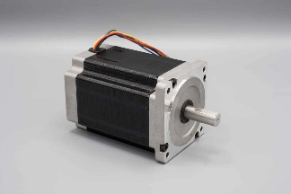

*Stepper motors are brushless DC actuators that convert digital pulses into precise mechanical steps, enabling open-loop position control without feedback. Hybrid designs (combining permanent magnets and toothed rotors) dominate high-performance applications, offering resolutions down to 0.9° per step. Micro stepping further enhances smoothness and precision by subdividing steps electronically. While their deterministic operation excels in CNC, 3D printing, and robotics, steppers face limitations like step loss under load and inefficiency at high speeds. Advanced drivers now integrate sensor less torque control and adaptive algorithms, narrowing the gap with servo systems. Innovations in materials and control continue to expand their role in precision automation and biomedical engineering.*

***IMAGE PROSESSING CAMERA***

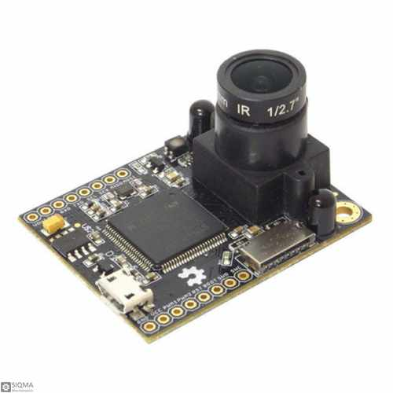

*Image processing cameras merge optics, AI, and computational algorithms to intelligently interpret visual data. They utilize high-precision sensors (CCD/CMOS) and real-time ISP adjustments for dynamic optimization. Advanced techniques—CNNs, frequency-domain transforms, and edge computing—enable real-time object detection, 3D reconstruction, and anomaly recognition. Applications range from industrial hyperspectral imaging to autonomous vehicles with LiDAR fusion. Emerging neuromorphic sensors mimic biological vision, enabling ultra-low-power event-based processing. These systems transcend passive capture, evolving into adaptive perceptual platforms with embedded AI for contextual awareness. The future lies in self-optimizing cameras that learn and process data autonomously, blurring the line between sensing and cognition.*

***MOTOR DRIVER (PCA9685)***

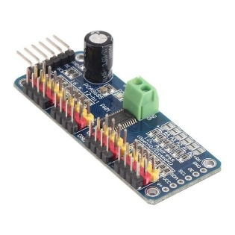

*Motor drivers bridge low-voltage control circuits and high-power motors, using H-bridge topologies (MOSFETs/IGBTs) for bidirectional PWM control. Modern versions integrate current sensing, thermal protection, and fault detection. Stepper/BLDC motors employ microstepping and field-oriented control for precision. Digital interfaces (SPI/I²C) enable networked industrial/robotic control. Emerging wide-bandgap semiconductors (SiC/GaN) enhance switching speeds and thermal efficiency, improving power density for next-gen motion systems.*

***Some other components and their Description:***

*The Arduino Uno's ATmega328P architecture exemplifies 5V TTL logic systems, requiring precise voltage translation when interfacing with 3.3V peripherals - a task addressed through MOSFET-based level shifters that maintain signal integrity while mitigating parasitic effects. Breadboard prototyping introduces measurable parasitic capacitance and contact resistance, challenging high-frequency signal preservation. Modern USB-to-Type-C interfaces must reconcile legacy protocols with contemporary power delivery specifications, presenting impedance matching challenges. Power adapters complete this ecosystem, where switching regulator artifacts necessitate careful noise suppression. This component ensemble embodies the fundamental trade-offs between accessibility and electrical fidelity in experimental electronics, where every interconnection represents a compromise between ideal theory and practical implementation.*

***Contributions:***

*Our team researched double-door mechanisms, analyzing pivot dynamics, torque needs, and sensor integration while exploring automated single-door conversion. Through collaboration, we evaluated actuators, control methods, and safety features, establishing key technical parameters for our adaptive door prototype.*

***Harsh:*** *Researched on the different types of electronic components required for automating double door swing mechanism (PIR sensors), project weekly report and finalisation of materials*

***Aditya:*** *Researched on the different types of electronic components required for automating double door swing mechanism (Microwave sensor, Motor Drivers)*

***Ayush:*** *Researched on the different types of electronic components required for automating double door swing mechanism (Servo and Stepper Motors)*

***Shreshth:*** *Researched on methods to switch between Double door and Single door mechanism (Image Processing Camera) and purchase of materials*

**Week 3: Research on Mechanism Proposed and its Finalisation and Final Dimensioning**

***Introduction:***

*This research presents a mechanically adaptive door system using precision laser-cut components to switch between single/double-door configurations. The 3mm birch plywood frame (±0.1mm tolerance) features integrated dovetail joints and bearing-mounted hinges for structural precision. A dual-mode mechanism combines magnetic couplers with solenoid-actuated locking pins engaging laser-drilled receptacles. Motion is controlled by a four-bar linkage with laser-cut cam profiles, while torsion springs (k=0.8Nm/rad) and counterweights ensure balanced operation. This purely mechanical design demonstrates how laser cutting enables reconfigurable architectural systems with exceptional precision, offering energy-efficient operation without complex electronics. The system maintains robust performance through optimized mechanical interactions rather than motorized components.*

***Brief view on Mechanism Proposed:***

***Dimensioning and Laser Cutting:***

***Contributions:***

**Week 4: Preparation of the Lab Project**

**Week 5: Preparation of the Lab Project**

**Week 6: Final checking and completion of Lab Project**

**PROJECT REPORT**

HARSH ALOK SHAH 2023MEB1344

AYUSH KUMAR SAW 2023MEB1331

SHRESTH SHUKLA 2023MEB1379

ADITYA SHARMA 2023MEB1325

**DETAILED DESCRIPTION OF EACH MATERIAL USED IN THE PROJECT**

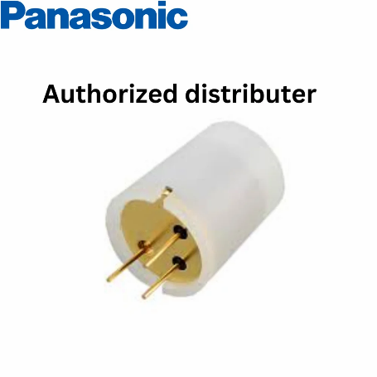

A PIR (Passive Infrared) sensor detects motion by sensing infrared radiation from objects, especially humans. It triggers output when movement changes detected IR levels. PIR sensors are highly energy-efficient, consuming minimal power, making them ideal for battery-operated systems. They are cost-effective and widely used due to their affordability. By detecting human presence based on body heat, they reduce false triggers from inanimate objects, ensuring reliable operation. Additionally, their simple design allows easy integration with microcontrollers and automation systems.

**MICROWAVE SENSOR (HB100)**

A **microwave sensor** detects motion using the **Doppler effect**, analysing frequency shifts in reflected microwave signals. It offers a **longer range**, works in **all conditions** (darkness, fog, through walls), and detects **small movements**. Microwave sensors offer a longer detection range compared to PIR sensors, making them suitable for larger areas. They function effectively in all conditions, including darkness, fog, and even through thin walls or glass. With higher sensitivity, they can detect even the slightest movements, making them ideal for high-security applications. Furthermore, their detection area is adjustable, allowing fine-tuning to minimize false alarms.

Modern door automation systems often utilize a combination of PIR and microwave sensors to improve accuracy. PIR sensors ensure energy efficiency by detecting human presence, while microwave sensors provide precise motion detection, reducing false alarms and enhancing security. This hybrid approach optimizes performance, ensuring reliable and efficient door automation.

**SERVO MOTOR (HD-1581HB)**

-

Servo motors are preferred over other types of motors in applications requiring precision, controlled motion, and reliability. Here is why:

1. High Precision & Accuracy

Servo motors offer precise angular control (typically within 0.5° to 1° accuracy).

Ideal for robotics, CNC machines, automated systems, and model gearboxes where exact positioning is required.

2. Closed-Loop Control System

Uses feedback mechanisms (like encoders or potentiometers) to maintain accurate positioning.

Unlike DC motors, servos automatically correct any deviations in movement.

3. High Torque at Low Speeds

DC motors lose torque as speed decreases, but servos maintain high torque even at low RPM.

Useful for applications needing controlled force, like automated gear shifting or robotic arms.

**IMAGE PROSESSING CAMERA**

**MOTOR DRIVER (PCA9685)**

Why Use Arduino Over Other Microcontrollers for Door Mechanisms?

Arduino is a popular choice for automated door mechanisms due to its ease of use, flexibility, and large community support. Here is why it stands out compared to other microcontrollers like PIC, Raspberry Pi, or ESP8266:

1. Ease of Programming & Development

Uses Arduino IDE, which is beginner-friendly and has a simple syntax.

Has pre-built libraries for sensors like PIR, microwave, servo motors, etc.

Uses C/C++, which is easier to learn compared to assembly languages used in some microcontrollers.

2. Large Community & Support

Thousands of tutorials, forums, and open-source projects help in troubleshooting.

Extensive documentation simplifies integration with sensors and actuators.

3. Cost-Effectiveness

Affordable compared to many other microcontrollers.

Arduino Uno or Nano can handle basic door automation tasks at a low cost.

4. Wide Sensor & Module Compatibility

Supports PIR, microwave sensors, RFID, fingerprint scanners, and keypads.

Has multiple I/O pins to connect multiple devices easily.

5. Real-Time Processing & Quick Response

Fast processing speed for real-time motion detection.

Reliable for automatic doors that require quick opening/closing actions.

6. No Operating System Required

Unlike Raspberry Pi (which runs Linux), Arduino runs code directly.

Boots instantly and consumes less power.

7. Low Power Consumption

Uses low power, making it ideal for battery-operated or energy-efficient door systems.

When to Use Other Microcontrollers?

Raspberry Pi → If you need advanced features like AI-based facial recognition.

ESP8266 / ESP32 → If WIFI or IoT connectivity is required.

PIC/STM32 → If power efficiency and industrial-grade reliability are needed.

**Contribution**

**Ayush** PIR, Servo Motor

**Aditya** Microwave sensor, Camera

**Harsh** Mechanism, Motor Driver, designing

**Shresth** Material ordering, CV coding